Case Management to Care Management Training Workbook for Kids Case to Care

Introduction: This workbook is designed to accompany the Kids Case Management to Care Management training. It contains handouts, resources and optional activities for use during and after the case to care training. All websites provided contain information that is in the public domain and can be used for education with people you serve.

We are delighted to bring this training to you and hope you find it helpful in your on-going professional development.

How to support partnership development with community based primary care providers:

- Establish the relationship:
  - Get to know office staff
  - Provide written information about your navigation services
  - Ask for your business card to be stapled inside the chart and/or entered in the electronic record.
  - Provide information about how you can help PCP:
    - Giving current medication information
    - Supporting the person in the waiting room and on their visit
    - Clarifying instructions after the visit.
    - Following through on what you commit to do.
    - Being available for questions from PCP.
  - Establish an update form that can be faxed to PCP with med changes and that can be taken to visit by person and faxed back to you by PCP. Should include any med changes, any concerns, and any hospitalizations.

- Before the visit:
  - Clarify with the parent/child what their hopes are for the visit:
    - Concerns
    - Questions they hope to have answered
    - What will happen if they need to wait in a crowded waiting room
  - Clarify how they want you to support them:
    - Reminding them of their agenda?
    - Stepping in if need be to clarify their agenda?
    - Asking questions?
    - Being a quiet support presence.
  - Educate on effective communication with PCP:
    - Focused, brief and honest
    - More facts than feelings
  - Prepare the pre-visit form: write down the questions and concerns that you have identified together, make sure you have a list of current medications (or that the person brings all current meds to the PCP visit).

Primary Care Visit Agenda

What am I concerned about for my child or myself?

What questions do I have?

What support do I need/want on this visit (i.e. help me speak up, remind me of my questions or if I get overwhelmed speak for me)?

What medications is my child taking and how (list everything, even vitamins, supplements and over the counter medication)?

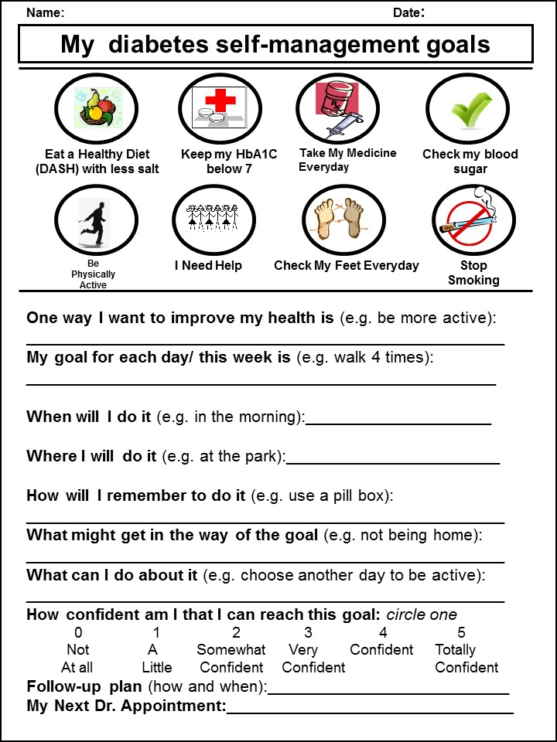

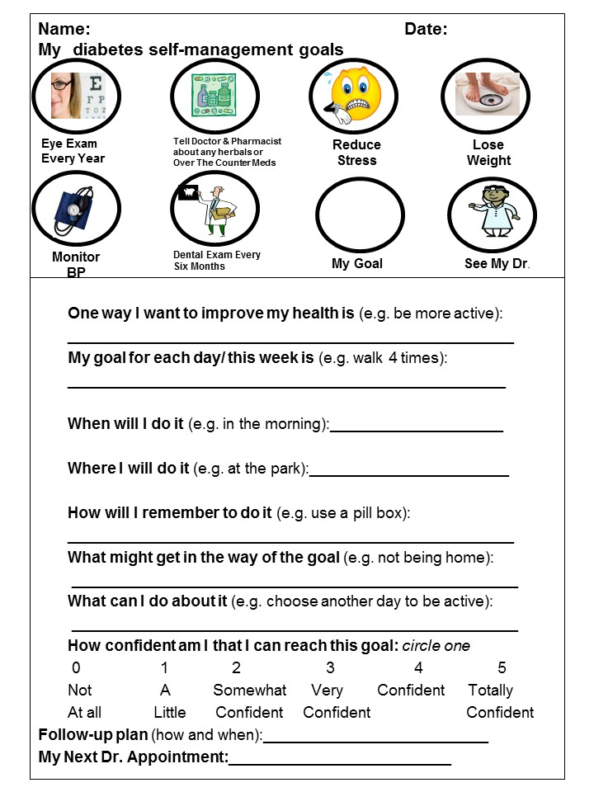

EATING, MOVING AND OVERALL HEALTHY LIVING RESOURCES

- DASH diet: http://www.mayoclinic.com/health/dash-diet/HI00047
- Livestrong.com
- Choose my plate.gov
- Healthyeating.nhlbi.nih.gov
- www.eatright.org
- 23 and ½ hours: what’s the single best thing we can do for our health: YouTube video, https://www.youtube.com/watch?v=aUaInS6HIGo

ADDITIONAL RESOURCES

Center for Integrated Health Solutions: http://www.integration.samhsa.gov/

This website has resources on critical topics including: smoking cessation, what works in health behavior change, toolkits around diet/exercise and smoking, confidentiality and business agreements and many other topics.

Case to care resource page: http://www.nationalcouncildocs.net/case-to-care
This is a website maintained by the integrated health team that has current resources related to topics covered in the training. Check back frequently as we are always updating and adding more information to this.

TEAM PLANNING ACTIVITY

Background: Hopefully you have found the content of the Case Management to Care Management training helpful. Training is only as good as what happens with it the next day when you get to work and so we are inviting you into this team planning activity.

Think about a change in your practice you as a team can commit to make in the next 30-60 days to help the kids you serve get healthier. The key word here is COMMIT and to identify HOW YOU WILL KNOW IT IS DONE. The execution doesn’t have to be perfect, the goal is to do something new, to expand on something you are already doing that will move your team into closer and closer alignment with the vision of health homes. This practice change should be something you can see, that there is clear accountability for and a clear timeline and plan for implementation.

What we are trying to accomplish | Steps to get there | Target dates for implementation (when will we start) | When will we check in? | Who will hold us accountable:
An example: As a team we want to be more effective in increasing the physical activity of the people we serve. | -Create this as a standing agenda item for our team meeting  -Beginning on (date) each team member will engage in a conversation with one participant and develop a concrete plan for increasing exercise.  -the plan will include small steps, date to check back with them.  -each team member will gather ideas on increasing physical activity from internet. | Start date | Date of team meeting to check in | Name of team leader or whoever takes responsibility for making sure this happens
What you want to accomplish | Concrete steps to get there | When will we start? | When will we check in? | Who owns this plan?

